# **EXPERIMENT – 6**

**Aim:** To implement the DNS using Cisco Packet Tracer.

**Theory:** The Domain Name System (DNS) is like the internet's address book. It helps us find websites easily by translating human-friendly names (like [www.example.com](http://www.example.com/)) into computer-friendly IP addresses. Without DNS, we'd have to remember a bunch of numbers to visit websites, which wouldn't be very convenient.

DNS works in a distributed way, with different servers managing different parts of the internet. This structure makes sure that if one server isn't working, there's usually another one that can help. It's like having backup plans in place.

In essence, DNS makes navigating the internet simpler for us by handling the translation between names we recognize and the numbers computers use to identify websites. It's a crucial part of what makes the internet user-friendly and reliable.

**Procedure:**

1. Open Cisco Packet Tracer and create a new project.
2. Drag and drop one “PC” from and one Server from “End Devices”
3. Drag and drop the “2960” Switch from “Switches” and place it in between the server and the PC.
4. Now connect the server and the PCs to the switch using the “Copper Straight Through” wire.
5. Double-click on the Server and go to “Desktop”.
6. Now in the “IP Configuration”, click on static and put it in the IPv4 address as 192.168.0.1 and click on the subnet mask(255.255.255.0).
7. Also, in “DNS server”, put the current DNS server address i.e., 192.168.0.1.
8. Now go to the “Services” section in the Server and click on DNS.
9. Toggle the DNS service “ON”.
10. Write the domain name for the server in name under Resource Records section (for example: server.com)
11. Write down the corresponding IPv4 address of domain name entered previously. (for example: 192.168.0.1)
12. Click on “Add”, and then on “Save” to register the name in DNS table.
13. Exit the Server and Double-click on PC, then go to “Desktop”.
14. Go to the “IP Configurations” and set a random IPv4 address for the PC.
15. Now, in the “DNS Server”, put the IP address of the DNS server i.e., 192.168.0.1.
16. Exit the “IP Configurations” and Double-click on the “Web Brower” to open it.
17. Write the previously defined “domain name” in the search bar. (server.com)
18. Press Enter, and wait for server to respond.
19. You shall see the standard html page of Cisco Packet Trace

**Project Setup**

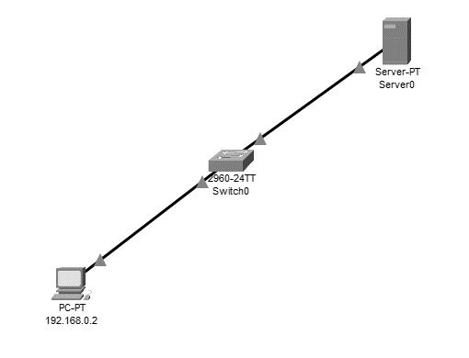

**IP Configuration of Server**

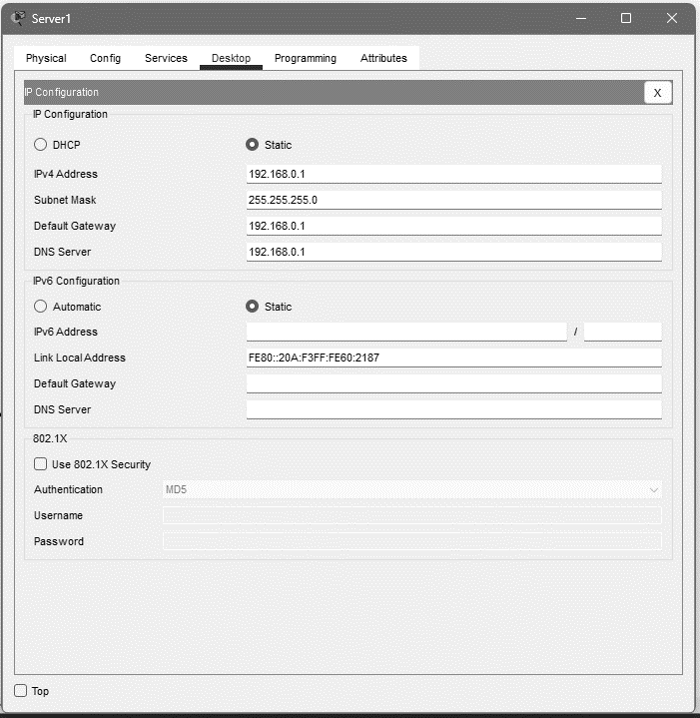

**DNS setting of Server**

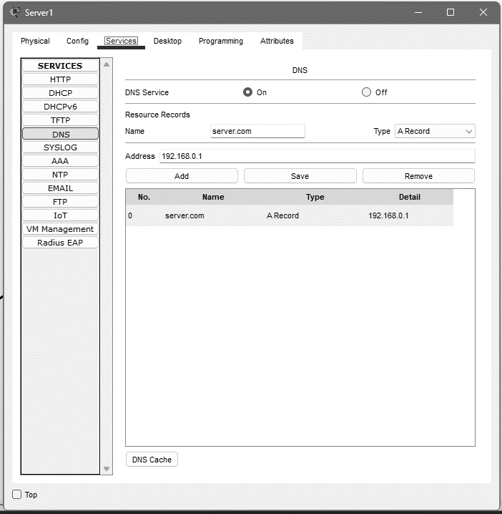

**IP Configurations of PC**

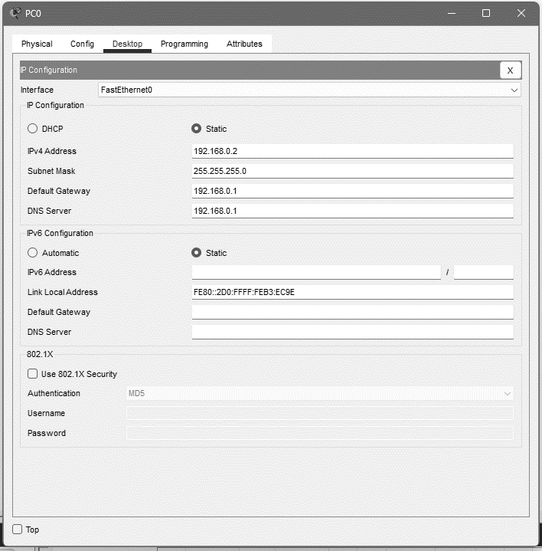

**Web browser on PC**

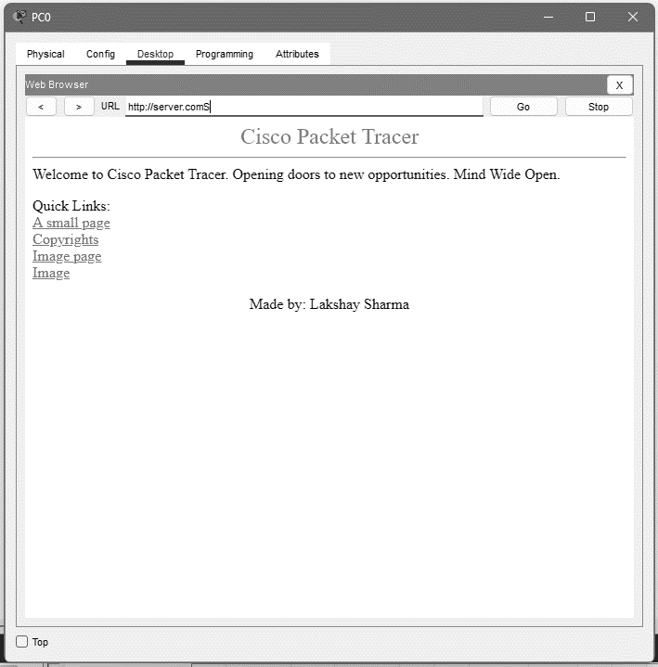

# **EXPERIMENT – 7**

**Aim:** To implement the SMTP between two devices using Cisco Packet Tracer.

**Theory:** SMTP, or Simple Mail Transfer Protocol, is referred as the internet's postal service, ensuring the reliable transmission of emails. It operates as a communication protocol, delineating how computers send and receive mail messages across networks. The process involves two key players—the sender's SMTP server and the receiver's SMTP server. When you click "Send," your email is dispatched to your SMTP server, which meticulously follows the email format, encompassing headers, message body, and attachments, to facilitate efficient transmission.

SMTP serves as a routing guide, directing the email from the sender's server to the recipient's server. However, it doesn't deposit the email directly into the recipient's inbox; rather, it acts like a relay, utilizing intermediate servers if necessary. The reliance on port 25 for communication is a hallmark of SMTP, although secure variants like SMTPS and STARTTLS on different ports enhance data protection during transmission. Authentication mechanisms are often employed by SMTP servers to safeguard against unauthorized access, ensuring that only legitimate users can dispatch emails through a specific server.

**Procedure:**

1. Open Cisco Packet Tracer and create a new project.
2. Drag and drop two “PCs” from and one Server from “End Devices”
3. Drag and drop the “2960” Switch from “Switches” and place it in between the server and the two PCs.
4. Now connect the server and the PCs to the switch using the “Copper Straight Through” wire.
5. Double-click on the Server and go to “Desktop”.
6. Now in the “IP Configuration”, click on static and put it in the IPv4 address as 192.168.0.1 and click on the subnet mask(255.255.255.0).
7. Now go to the “Services” section in the Server and click on “Email”.
8. Enter the domain name for the email server (for example: lakshay.com) and click on “Set”.
9. Add the username and password for the two PCs.

(user: king, password: cisco) (user: queen, password: cisco)

1. Double-click on the PC and go to “Desktop”.
2. Now, in the “IP Configuration”, click on static and put a random IPv4 address.
3. Next, in the “Email”, enter the user information as: name (from one of the registered names in email server), for example: king.
4. Then, enter the email address as king@lakshay.com, username followed by domain name for email server.
5. For both “Incoming Mail Server” and “Outgoing Mail Server”, set it to the email server’s IP address. (192.168.0.1)
6. Enter the “Logon Information” as the same entered in email server i.e., username: king, password: cisco.
7. Do the same for the second PC (user: queen).
8. From the first PC, Now, write an email to the second PC by using it email address.
9. Press “Send”. And click on “Receive” on the second PC.
10. You should receive a email from the first PC.

**Project Setup**

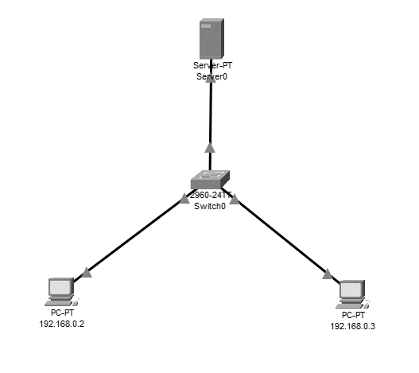

**Email Service Setup on Server**

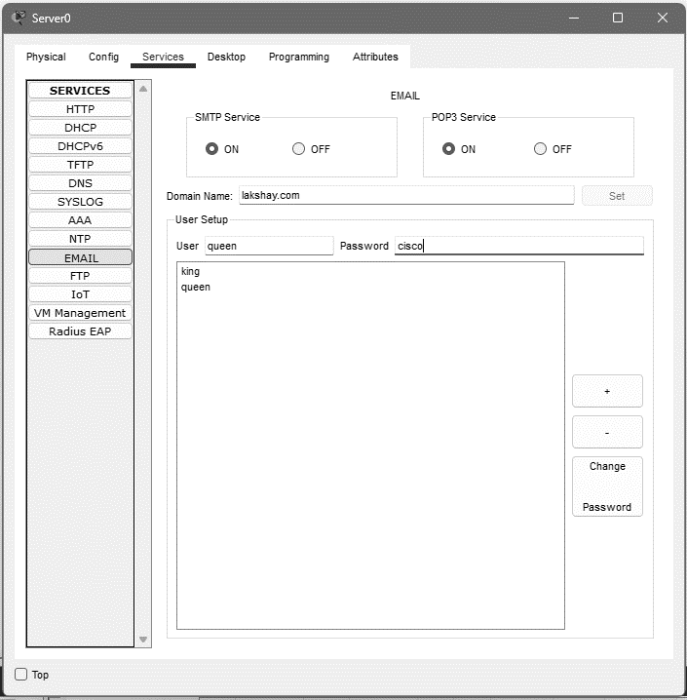

**Mail Configuration of First PC**

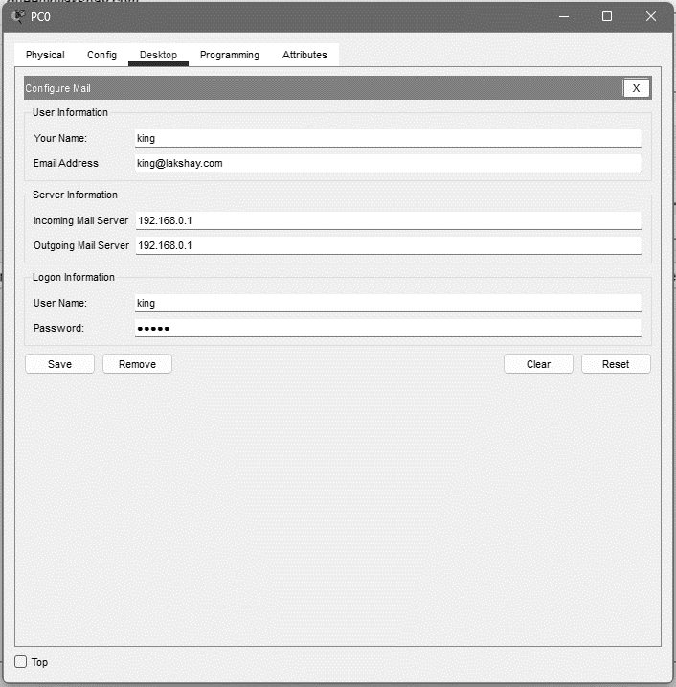

**Mail Configurations of Second PC**

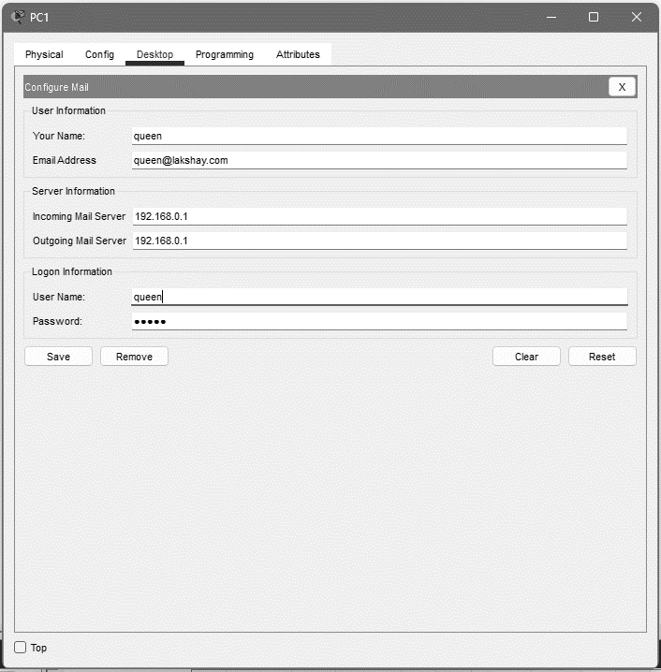

**Sending Email from the First PC**

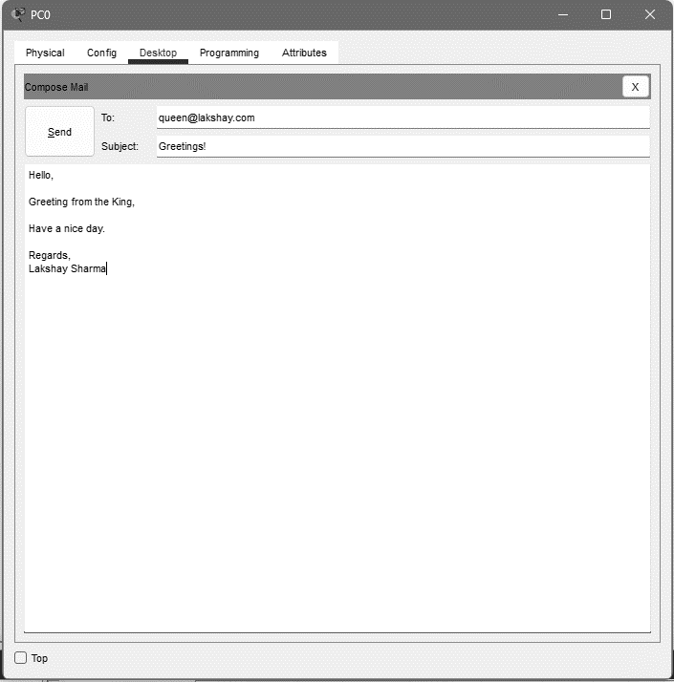

**Receiving Email on second PC**

